**HUMAN RESOURCES DEVELOPMENT STRATEGY USE**

**BACKPROPAGATION ARTIFICIAL NEURAL NETWORKS**

**Erwin Panggabean1*, Arjon Samuel Sitio 2, Yulianto Lase 3, Diana Junita 4**

**1234STMIK Pelita Nusantara Medan, Sumatera Utara, Indonesia**

[**1erwinpanggabean9@gmail.co**](mailto:1erwinpanggabean9@gmail.com)**m,2**[**arjonsitio@yahoo.com**](mailto:arjonsitio@yahoo.com)**, 3**[**yulianto.lase@gmail.com**](mailto:yulianto.lase@gmail.com)**, 4dianajunita10@gmail.com**

**Submitted** : MM DD, YYYY | **Accepted** : MM DD, YYYY | **Published** : MM DD, YYYY

Abstract: The strategy for developing human resources for recruitment so that at the same time becoming a reliable workforce as expected is the goal of personnel in certain offices or agencies. This step must be taken by the management of companies or institutions, both public and private, in order to improve human resources (HR). Until now, there has never been any research on the conventional acceptance of prospective employees to test how accurate their performance is. In this study the conventional selection system for prospective employees will be used as a basic concept to find methods for analyzing the performance of prospective employees using computer media with an artificial neural network system approach with the backpropagation method. So that the accuracy of the predictive patterns of prospective new employees is obtained. So that finally the personnel of government and private agencies obtain actual information about the performance of prospective employees who will be accepted as workers. The results of the study using hidden layers and learning constants obtained the fastest convergent value at 3377, and the final results of this study will be published in a national journal accredited SINTA 4 or better.

**Keywords: Recruitment strategy for new workers, artificial neural networks, backpropagtion, and human resources.**

**INTRODUCTION**

Recruitment of new employees is one of the steps taken by the management of companies or institutions, both public and private, in order to improve human resources (HR). Every year, government and private agencies usually require new employees to fill various employee formations in their respective institutions. The acceptance of these prospective employees is based on the terms and conditions in accordance with the HR competency standards of the institution so that the prospective employees will be able to improve the company's performance. Currently, employee recruitment is only based on portfolios and does not prioritize the skills or experience of the prospective employee concerned. This fact can be seen that there is an employee with higher education as evidenced by the existence of a diploma but in practice he is unable to carry out his duties at the agency, conversely there is an employee with low education but is able to complete the job well in his agency.

Predicting the quality of prospective employees according to the requirements required by institutions with conventional systems when accepting new employees by taking into account administrative requirements, potential tests, medical tests, of course these requirements do not guarantee that the prospective employees will be able to work well. Until now, there has never been a study that examines how accurate the accuracy of performance is. In this research, the conventional selection system for prospective employees will be used as a basic concept to find methods for analyzing the performance of prospective employees using computer media with an artificial neural network system approach. So that the accuracy of the predictive patterns of prospective new employees is obtained. So that finally the personnel of government and private agencies obtain actual information about the performance of the prospective employees they will receive. Through this research, it is hoped that in the end it will be able to provide a pattern, especially regarding the principles of accepting prospective private and government employees, so that it can provide output that is suitable for meeting HR needs in line with the requirements of skills, expertise and profession needed in realizing the tasks and functions Indonesia's institutions and development goals as a whole.

**LITERATURE REVIEW**

Artificial neural network is a computer program that can imitate thought processes and knowledge to solve a specific problem, decisions can be given intelligently. Backpropagation algorithm is one of the artificial neural network algorithms that is often used in solving complex problems because it has a good level of accuracy. The results of this study indicate that backpropagation has a good level of accuracy in predicting new students with a 5-1 neuron structure with 1 (one) hidden layer, the learning rate (lr) used is 0.1 and the MSE value is 0.001. The test was stopped at the 758th epoch, because the objective performance function had been reached (MSE = 0.000998685 <0.001) showing the relationship between the target and the network output during the test was good. From testing the test data between network outputs, the target correlation coefficient (R) is 0.98779, where the best result is 1(Nurhani et al.2018). Poverty is a problem that should be seen as a complex (multidimensional) social problem. Based on data from the Central Bureau of Statistics, the percentage of national poverty in March 2019 was 9.41 percent. Meanwhile, Central Java Province has a higher poverty rate than the national poverty rate of 10.8 percent. High levels of poverty can lead to criminal acts, high unemployment, social, political chaos and so on. Therefore, this study aims to analyze the level of poverty by determining the appropriate model which can then be used to predict poverty rates by district/city in Central Java Province. The data used was obtained from the Central Bureau of Statistics for Central Java Province from 2010 to 2019 which consists of data on Economic Growth Rates, Open Unemployment Rates, Human Development Index, and Poverty Rates by district/city. The method used is Backpropagation Neural Network. Backpropagation Neural Network has good performance in solving problems, one of which is the prediction problem. Based on the best architectural model produced in this study, namely the 3-35-1 architectural model, an accuracy rate of 95.2% can be obtained using MSE in the testing process using test data. So it can be concluded that the Backpropagation Neural Network by applying the right model can produce a good level of accuracy which can then be used as an alternative to predict poverty rates according to districts/cities in Central Java Province in the future, Metro Electronic and Furniture is a growing company in electronics and furniture sales (Finaliamartha et al., 2022). This company really wants to increase profits every month, so an application is needed by this company to determine product sales predictions every month. The artificial neural network system uses the backpropagation method which is applied in this study for product sales forecasting and is expected to help solve problems in product sales forecasting. Forecasting the product thus the expected result is to get accurate predictions for the next month for product sales at Metro Electronic and Furniture Sungai Full. In the process of processing data related to forecasting, the forecast pattern is in accordance with that determined by the backpropagation algorithm. An artificial neural network system using the backpropagation method is implemented using Matlab as software that supports product sales data from 2014 to 2016(Satria, 2021).

**METHOD**

**Back Propagation Neural Network Model**

The model of the neuron of the backward error propagation neural network is shown in the figure below

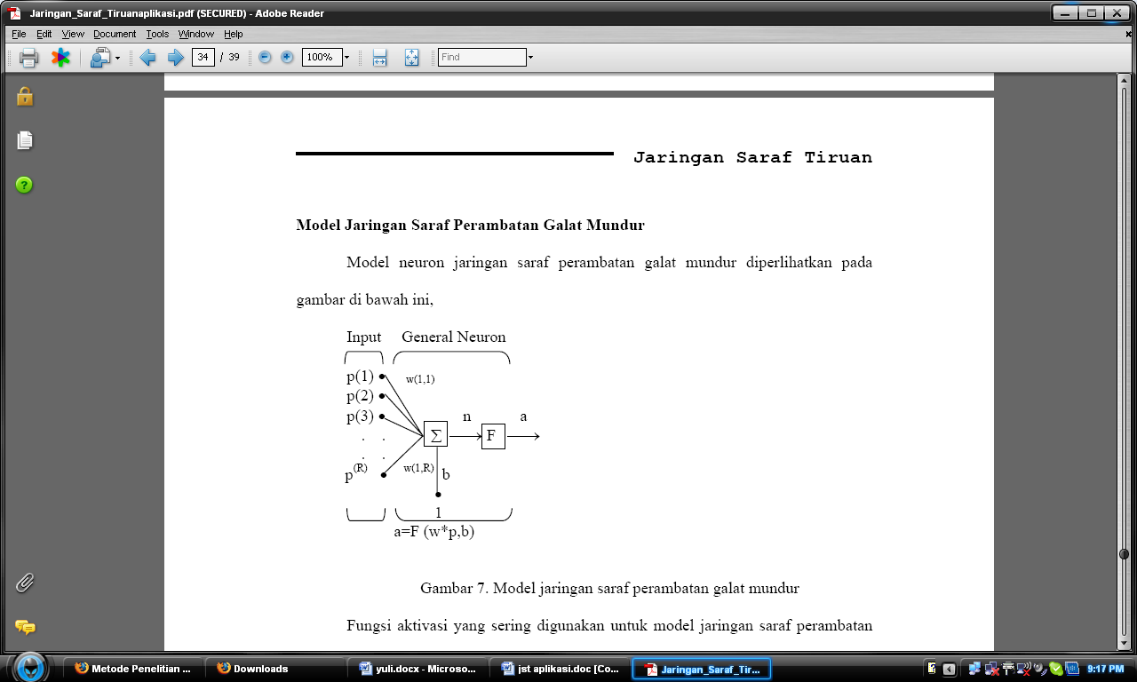



Figure 1 The backward error propagation neural network model

The activation functions that are often used for backward error propagation neural network models are logsig, tantig, and purelin (shown in the figure below).

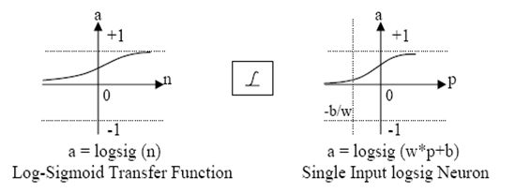

Figure 2 Logsig Activation Function

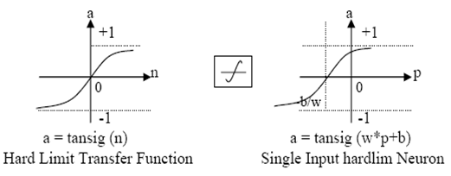

Figure 3 Hard limit Transfer Activation Function

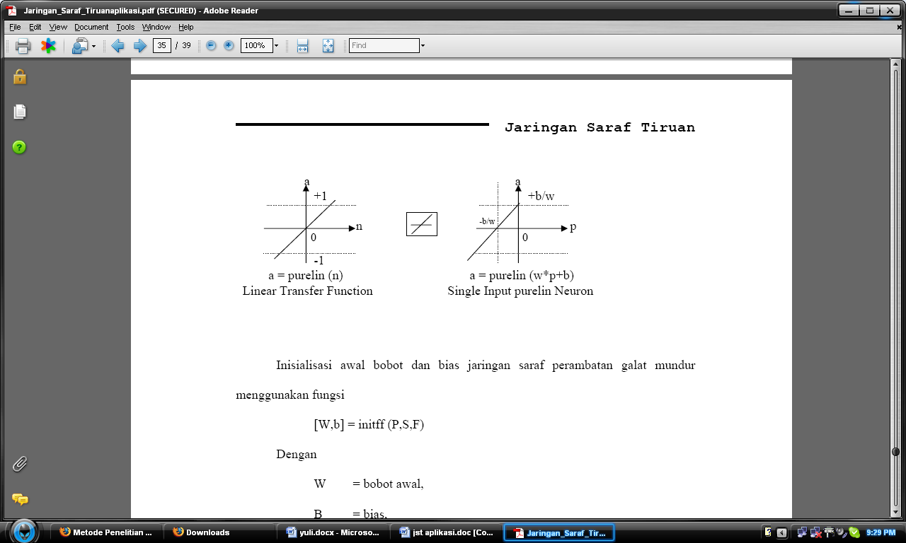



Figure 4 Linier Transfer Function

Initialize the initial weights and bias the backward error propagation neural network using the function

[W,b] = initff (P,S,F)

With

W = initial weight,

B = bias,

P=input pattern,

S = number of neurons,

F = activation function used.

If the backward error propagation neural network model used consists of an input layer, a hidden layer and an output layer, then the initialization function becomes

[W1,b1,W2,b2] = initff(P,S1,F1,S2,F2)

After initialization, the backward error propagation neural network is ready to be trained with a function (for example, there are three layers)

[W1,b1,W2,b2,epoch,tr] = trainbp (W1,b1,F1,W2,b2,F2,p,t,tp)

With

W1,W2 = neural network weights,

b1,b2 = biases,

epoch = number of iterations,

tr = number of errors,

F1,F2 = activation function,

P = pattern,

T = targets

tp= [disp_freq max_epoch err_goal lr]

With

Disp_freq=display interval,

Max_epoch = maximum number of iterations,

Err_goal= allowed error value,

Lr= learning rate/learning constant

After the final weights are generated, the backward error propagation neural network can be tested with a function

A = Simuff (P,W1,b1,F1,W2,b2,F2)

In addition to the trainbp function which is often used to train backward error propagation neural networks, other functions are also known, such as trainbpm and trainbpx.

Trainbpm is the training of a backward error propagation neural network with additional momentum, the form of the function is as follows

[W1,b1,W2,b2,epoch,tr] = trainbp (W1,b1,F1,W2,b2,F2,p,t,tp)

Tp = [disp_freq max_epoch err_goal lr momentum err_ratio]

With Disp_freq = display interval

Max_epoch = maximum number of iterations,

Err_goal= allowed error value,

Lr= learning rate/learning constant,

Momentum = momentum constant

Err_ratio = error ratio

Trainbpx is a backward error propagation neural network training with additional momentum and adaptive learning constants, the form of the function is as follows

[W1,b1,W2,b2,epoch,tr] = trainbpx (W1,b1,F1,W2,b2,F2,p,t,tp)

With tp =

Tp(1) = view interval,

Tp(2) = maximum number of iterations,

Tp(3) = allowed error value,

Tp(4) = learning constant,

Tp(5) = learning constant increase,

Tp(6) = learning constant derivation,

Tp(7)= momentum,

Tp(8) = error ratio.

**RESULT**

The training process is carried out using MATLAB software. MATLAB has provided a training and testing toolbox on artificial neural networks with backpropagation algorithms. The training process is carried out to find the best configuration by changing the learning constants and the number of hidden layers by trial and error. The results of the training are shown in Table 1 below:

Table 1. Training Results with changes in learning constants and number of hidden layers

|  |  |  |  |
| --- | --- | --- | --- |
| KB  LT | 0,01 | 0,02 | 0,05 |
| 10 | 38761 | 13785 | TK |
| 20 | 29115 | 12034 | 47373 |
| 30 | 17165 | 11365 | 72007 |
| 40 | 16484 | 8920 | 6986 |
| 50 | 17421 | 8815 | 7810 |
| 60 | 14784 | 7017 | 8328 |
| 70 | 13270 | 6643 | 4012 |
| 80 | 13506 | 6770 | 4149 |
| 90 | 12722 | 6280 | 3377 |

Explanation:

KB = Learning Constant

LT = hidden layer

TK = Not Convergent

Testing is carried out in 2 stages, first testing on data on the results of the performance of trained employees and secondly testing on data on new employees who have never been trained before. The results of testing on 25 new employee data are obtained as follows:

Table 2 Test Results for Trained Employee Data

|  |  |  |  |  |  |  |  |  |  |
| --- | --- | --- | --- | --- | --- | --- | --- | --- | --- |
| Number  Respondents | New Employee Requirements | | | | | | Performance | Target | OJ |
| Administration | Psychological Test | English Test | Interview | Medical check up | Academic Potential Test |
| 1 | 7,90 | 6,68 | 8,48 | 7,00 | 6,96 | 7,63 | 92 | 01 | 01 |
| 2 | 7,92 | 6,82 | 8,19 | 7,86 | 6,77 | 9,64 | 94 | 01 | 01 |
| 3 | 7,96 | 6,98 | 9,72 | 8,22 | 6,68 | 8,47 | 94 | 01 | 01 |
| 4 | 7,72 | 6,52 | 8,82 | 8,43 | 7,06 | 8,21 | 93 | 01 | 01 |
| 5 | 7,54 | 6,82 | 8,82 | 7,45 | 6,41 | 8,79 | 94 | 01 | 01 |
| 6 | 7,53 | 6,98 | 9,29 | 8,22 | 7,06 | 8,47 | 94 | 01 | 01 |
| 7 | 7,25 | 7,15 | 8,82 | 7,71 | 6,59 | 7,8 | 95 | 01 | 01 |
| 8 | 7,71 | 7,54 | 9,29 | 7,58 | 6,77 | 7,33 | 95 | 01 | 01 |
| 9 | 7,04 | 6,98 | 10 | 7,71 | 7,06 | 8,21 | 95 | 01 | 01 |
| 10 | 7,51 | 6,4 | 8,82 | 8,03 | 7.4 | 7,99 | 94 | 01 | 01 |
| 11 | 7.72 | 8,01 | 8,48 | 7,33 | 9,96 | 8,47 | 94 | 01 | 01 |
| 12 | 7,96 | 7,76 | 9,72 | 7,45 | 6,77 | 7,63 | 95 | 01 | 01 |
| 13 | 7,54 | 6,27 | 8,82 | 8,68 | 6,77 | 8,21 | 94 | 01 | 01 |
| 14 | 7,06 | 7,15 | 7,95 | 7,45 | 6,77 | 7,8 | 94 | 01 | 01 |
| 15 | 7,96 | 6,98 | 8,19 | 7,86 | 7,53 | 7,99 | 95 | 01 | 01 |
| 16 | 8,9 | 6,15 | 8,19 | 8,43 | 6,96 | 8,79 | 96 | 10 | 10 |
| 17 | 7,37 | 6,68 | 8,48 | 7,71 | 6,5 | 7,99 | 96 | 10 | 10 |
| 18 | 7,37 | 6,53 | 9,29 | 8,03 | 7,17 | 8,21 | 96 | 10 | 10 |
| 19 | 8,21 | 7,34 | 8,82 | 8,22 | 7,28 | 8,47 | 96 | 10 | 10 |
| 20 | 7,37 | 6,53 | 9,29 | 8,03 | 7,17 | 8,21 | 96 | 10 | 10 |
| 21 | 8,21 | 7,34 | 8,82 | 8,22 | 7,28 | 8,47 | 96 | 10 | 10 |
| 22 | 7,37 | 6,53 | 9,29 | 8,03 | 7,17 | 8,21 | 96 | 10 | 10 |
| 23 | 8,21 | 7,34 | 8,82 | 8,22 | 7,28 | 8,47 | 96 | 10 | 10 |
| 24 | 7,45 | 8,11 | 9,7 | 8,35 | 6,31 | 8,72 | 97 | 10 | 10 |
| 25 | 7,74 | 6,98 | 9,29 | 7,58 | 7,17 | 7,8 | 97 | 10 | 10 |

The table above shows that the training performed by the artificial neural network reaches 100%. This is due to the training output displayed by the computer in accordance with the specified target. From the research results obtained the best pattern of experimental results as follows:

The configuration of the artificial neural network used.

**DISCUSSIONS**

The use of ANN with the backpropagation method as a tool for human resource development is one of the innovative approaches in dealing with challenges in managing human resources. ANN is a mathematical model that can recognize patterns or relationships in data, while backpropagation is a training method in ANN that can optimize the weight and bias in the network so that the network can learn from the data.

Advantages of Using ANN with the Backpropagation Method in HR Development The use of ANN with the backpropagation method in HR development has several advantages. First, ANN's ability to recognize patterns in data can be used to understand employee characteristics, including their strengths, weaknesses, and potential. With a better understanding of employee characteristics, HR development strategies can be designed more effectively and efficiently. Second, the backpropagation method as a training technique in ANN can optimize network performance by reducing prediction errors. Thus, the use of ANN with the backpropagation method can improve accuracy in identifying employee HR development needs. Third, ANN can be used to make predictions regarding employee career development, such as potential for promotion or promotion. This can help organizations plan employee career development more effectively.

Challenges in the Use of ANN with the Backpropagation Method in HR Development Although it has potential in developing human resources, the use of ANN with the backpropagation method also has several challenges. First, sufficient and quality data is needed to train the network to produce accurate predictions. Without sufficient data, the network may generate inaccurate or even incorrect predictions. Second, understanding the output and interpretation of ANN in HR development can be complex, because ANN is a complex model for recognizing patterns in data. Therefore, a good understanding of the basic concepts of ANN and backpropagation methods is important to ensure truly beneficial results in HR development. Third, the use of ANN with the backpropagation method also requires information technology resources.

**CONCLUSION**

From the results of calculations using each sigmoid function, and with the implementation during the research using mathlab the learning constants are varied by 0.01, 0.02 and 0.05, so that for further research the learning constants are more varied so that the training program will produce the really best one exactly 1 (exact = 1). This is because the convergence of artificial neural networks can be done quickly if the learning constants and the number of hidden layers match.

**REFERENCES**

Finaliamartha, D., Supriyadi, D., Banyumas, K., Correspondence, P., Open, T. P., Humans, P., & Poverty, T. (2022). For Predicting Poverty Levels in Central Java Province Implementation of Backpropagation Artificial Neural Network. 9(4), 751–760. https://doi.org/10.25126/jtiik.202294806

Handayani, K. S., Lumbanbatu, D. K., & Kom, M. (2021). Prediction of Student Competency Test Scores with Backpropagation (Case Study of Jabal Rahmah Stabat Vocational School). 14(1), 73–80.

Irianti, A., Rantelinggi, P. H., Taufik, A., Zulkarnaim, N., & Cokrowibowo, S. (2022). Implementation of Backpropagation Artificial Neural Network for Food Price Prediction in Majene Central Market. Journal of Informatics Engineering (JUTIF), 3(3), 681–688. https://doi.org/10.20884/1.jutif.2022.3.3.226

Lesnussa, Y. A., & Risamasu, E. (2020). Application of Backpropagation Neural Networks to Forecast the Open Unemployment Rate (TPT) in Maluku Province. Science: Scientific Journal of Mathematics and Natural Sciences, 17(2), 89. https://doi.org/10.31851/sainmatika.v17i2.3434

Maiyuriska, R. (2022). Application of Artificial Neural Networks with Backpropagation Algorithm in Predicting Rice Grain Yields. Journal of Business Economics Informatics, 4, 28–33. https://doi.org/10.37034/infeb.v4i1.115

Nandel Syofneri, Sarjon Defit, & Sumijan. (2019). Implementation of the Backpropagation Method for Predicting Student Competency Test Pass Rates. Journal of Information & Technology, 1(4), 12–17. https://doi.org/10.37034/jidt.v1i4.13

Nurhani, L., Gunaryati, A., Andryana, S., & Fitri, I. (2018). Artificial Neural Network With Backpropagation Method To Predict Number Of New Students. National Seminar on Information Technology and Multimedia, 25–30.

Satria, W. (2021). Backpropagation Neural Network For Product Sales Forecasting (Case Study in Metro Electronic and Furniture). Djtechno: Journal of Information Technology, 1(1), 14–19. https://doi.org/10.46576/djtechno.v1i1.966

Suahati, A. F., Nurrahman, A. A., & Rukmana, O. (2022). Use of Artificial Neural Networks – Backpropagation in Predicting the Number of New Students. Journal of Engineering Media and Industrial Systems, 6(1), 21. https://doi.org/10.35194/jmtsi.v6i1.1589

Teguh Pradnyana Yoga, G., Dyana Arjana, G., & Mataram, I. M. (2020). Comparison of Training Function Combinations of Backpropagation Neural Networks in Load Forecasting. SPEKTRUM Journal, 7(1), 41. https://doi.org/10.24843/spektrum.2020.v07.i01.p6

Tambunan, H. T. B., Hartama, D., & Gunawan, I. (2021). Implementation of an Artificial Neural Network (ANN) to Predict the Amount of 3Kg Gas Sales Using the Backpropagation Method. Tin: Applied Archipelago Informatics, 1(9), 479–488.

Walker, E. G., & David, D. (2020). Application of Backpropagation Neural Networks in the TORCH Virus Diagnostic Expert System. Sysphotenika, 10(1), 87. https://doi.org/10.30700/jst.v10i1.947.